

Join the EDUC European Seminar for Doctoral and Post-doctoral researchers
Are you a young researcher eager to explore how to overcome key ethical challenges throughout the research process, combining theoretical perspectives with practical tools and hands-on activities?

Join us at the European Doctoral & Post-doctoral Seminar on New Ethical Challenges!

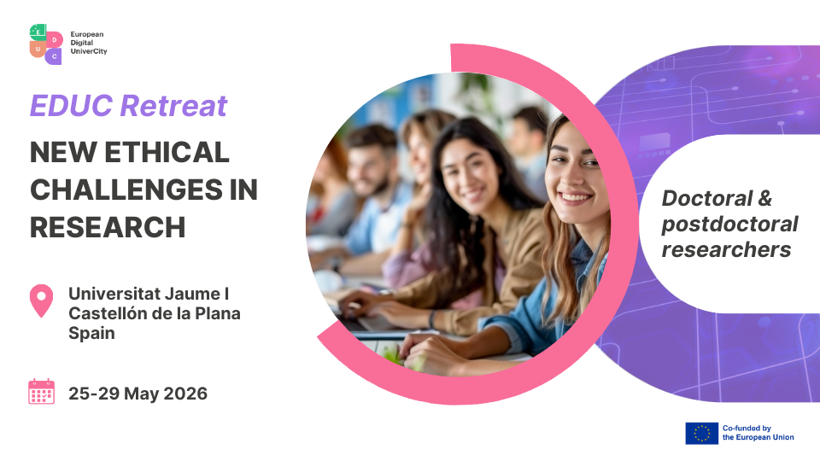

Organized by the EDUC European University Alliance, this event offers a unique opportunity to collaborate, learn, and innovate.
Venue: Unviersitat Jaume I, Castellón de la Plana, Spain
Date: 25-29 May, 2026
Who can apply: active PhD students of the University of Pécs
Application link: HERE
Why should you attend this seminar?
The “New Ethical Challenges in Research” retreat is a training initiative designed for doctoral candidates and early-career researchers from the EDUC alliance. In a rapidly evolving research landscape, integrity, transparency, and responsible conduct have become essential competencies for all researchers, regardless of discipline. This five-day (from the 25th to the 29th of May) programme addresses key ethical challenges that arise throughout the research process, combining theoretical perspectives with practical tools and hands-on activities. The retreat brings together specialists in research ethics, open science, responsible use of AI, predatory publishing, authorship practices, and ethical project design. Through plenary lectures, interactive workshops and a EDUC partners roundtable, participants gain a comprehensive overview of current debates and receive practical guidance on how to promote honest, rigorous and transparent research. The programme also fosters intercultural and interdisciplinary dialogue across the EDUC consortium, encouraging shared learning and collaborative reflection.

- Free participation
- EDUC grant, 1050 EUR/person for travel and accommodation
- All sessions in English
- Application required
Eligibility requirements: to participate, you must
- be enrolled in a PhD at the University of Pécs.
- have a minimum English proficiency level of B2.
- commit to attending the whole 5-day event.
Apply as of today
Secure your spot and be part of this exciting European seminar.
Application link: HERE
Application deadline: Sunday, 1 March 2026


Don’t miss this chance to engage, learn, and connect in an inspiring international setting.

Contact: educ@pte.hu
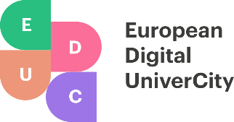
www.educalliance.eu






