April 27, Thursday

09:15 – 09:45 Onsite registration (Faculty of Business and Economics,
University of Pécs, Aula Magna foyer, Rákóczi út 80. 2nd floor)

09:45 – 10:15 Welcome addresses (Aula Magna)
    - Prof. Attila Miseta, Rector of the University of Pécs
    - Prof. Judit Kiss, President of the Africa Sub-Committee of the Hungarian Academy of Sciences
    - Dr. Agnes Ngoma Leslie, Coordinator of the China–Africa Working Group of the Center for African Studies, University of Florida
    - Prof. István Tarrósy, Director of the Africa Research Center and the International Center of the University of Pécs

10:15 – 11:00 AM Keynote lecture / Ian Taylor Memorial Lecture by:
Prof. Pádraig Carmody: ‘Post-peak China in Africa? Geopolitical Strategies’
followed by a Q&A until 11:30

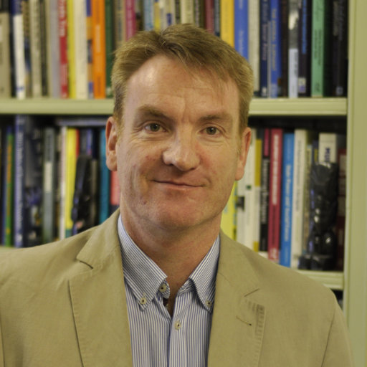 | Padraig Carmody is Professor of Geography at Trinity College, the University of Dublin (TCD). He is also a Senior Research Associate at the University of Johannesburg. His Ph.D. is from the University of Minnesota in the USA, where after graduation he taught at the University of Vermont. At TCD he directs the Masters in Development Practice and CHARM-EU. His research centres on the political economy of globalisation in Africa. He is the author of nine books and publishes regularly in journals such as European Journal of Development Research, Review of African Political Economy, Economic Geography and World Development. He is on the boards of Political Geography, African Geographical Review, Journal of the Tanzanian Geographical Society and Geoforum, where he was formerly editor-in-chief. He is currently associate editor of Transnational Corporations published by the United Nations Conference on Trade and Development. He is a Fellow of Trinity College and was elected to the Royal Irish Academy and the Royal Academy for Overseas Sciences in 2018. He has been Chair of the Development Studies Association of Ireland and is co-Chair of the Global Association of Masters in Development Practice and is a member of the Academic Advisory Committee of the Sustainable Development Goals Academy.
In this second Ian Taylor Memorial Lecture, Prof. Carmody will explore China’s increased engagements in Africa over the past two decades which have been as notable as they have been controversial. While some have predicted China’s economic stagnation as a result of issues such as debt, supply chain shortening as a result of the impact of COVID and the impact of strict lockdowns in that country, others see its economy dramatically rebounding. However, it appears that Chinese lending to Africa has now peaked and is in precipitous decline. Other powers are now vigorously contesting for space on the continent, with the US having emerged again as Kenya’s biggest trading partner, for example. This presentation will examine whether we are now in a period “post-peak China in Africa” and the reconfiguration of strategies of influence. This will have important implications for future politics and development on the continent.

11:30 – 12:50 Panel 1
Geopolitics, Current Conflicts and Their Implications
Chair: István Tarrósy, University of Pécs

11:30 – 11:50 The New Geopolitics of the Red Sea
László Csicsmann, Széchenyi University

11:50 – 12:10 Africa’s Stance in the Russia-Ukraine War: An Opportunity for Partnership
with China and Russia
Annie Abena Aku Agyemfra, Corvinus University of Budapest

12:10 – 12:30 Food Security in Egypt in the Shadow of the War in Ukraine
Rashed Daher, Eötvös Loránd University

12:30 – 12:50 Q&A debate

12:50 – 14:00 buffet lunch

14:00 – 15:30 Panel 2
African Perceptions and Agency in China-Africa Relations
Chair: Isabella Soi, University of Cagliari

14:00 – 14:20 African Perceptions of “China Model” of Development
Oscar Otele, University of Nairobi

14:20 – 14:40 Agency in China-Zambia Relations: Examining the Friction and Fluctuations in the “All Weather Friendship”
Agnes Ngoma Leslie, University of Florida

14:40 – 15:00 The Chinese Government Scholarship and its implications on African
Students in China Perception of Chinese Soft Power
Emmanuel Frimpong Sarpong, University of Nottingham (China Campus)

15:00 – 15:20 Q&A debate

15:20 – 15:40 coffee break

15:40 – 17:00 Panel 3
Asian and U.S. Perspectives, Soft Power and African Development
Chair: Ronnie Donaldson, Stellenbosch University

15:40 – 16:00 Rethinking Afro-Asian Relations – Japan’s Approach to African
Development
Pamela Chemelil, University of Pécs

16:00 – 16:20 The Compulsory Study of Mandarin by African Students in Chinese
Universities: A Soft Power Tool?
Emmanuel Frimpong Sarpong and Dominic Winston Kaku, University of Nottingham (China Campus)

16:20 – 16:40 From Scramble for to Harmony on Ethiopia
Alemseged Abbay, Frostburg State University

16:40 – 17:00 Q&A debate

17:00 – 18:20 Panel 4
Investment, Infrastructure and the Belt and Road Initiative (BRI)
Chair: Robert Klosowicz, Jagiellonian University

17:00 – 17:20 Another Chapter of China’s Railway Investment: The Cairo LRT
Zoltán Vörös, University of Pécs

17:20 – 17:40 The Impact of Chinese Investment on the Development of Djibouti's
Position in the Horn of Africa Region after 2016
Agata Markowska, Jagiellonian University

17:40 – 18:00 China’s Belt and Road Initiative in Nigeria: A Blessing or A Damp Squib?
Olutomiwa Binuyo, University of the Western Cape, South Africa
Emmanuel Ojekunle, The Sapphires Development Initiative, Nigeria
Oluwaseun Lawal, Lead City University, Nigeria.

18:00 – 18:20 Q&A debate

18:20 – 18:40 Presentation: Kenyatta University in the context of education and analytical chemistry research
Grace Bunyi and Mildred Nawiri, Kenyatta University

The Thursday evening program will be offered as part of the Annual Africa Days of the International Seasons 2023 of the University of Pécs.

19:30 – 21:00 Ballet Camara (Senegal) dance and music session

21:00 – 22:30 Tariqa (Morocco) concert

April 28, Friday

09:30 – 10:00 Wake-up coffee

10:00 – 11:50 Panel 5
Women and Development in Contemporary Morocco
Chair: Joanna Mormul, Jagiellonian University

10:00 – 10:10 Introduction to the Fulbright Field Study Seminar of MSU Denver in
Morocco, 2022
Akbarali Thobhani, Metropolitan State University of Denver

10:10 – 10:30 The Importance of Women Artists and Artisans to the Development of
Morocco in the Covid-19 Era
Leila Armstrong, Metropolitan State University of Denver

10:30 – 10:50 The Role of Women in the Development of the Moroccan Society from a
Political Science Perspective
Douglas Mpondi, Metropolitan State University of Denver

10:50 – 11:10 Social issues among Saharawi women living in Morocco, Algeria, and in the diaspora
Joanna Mormul, Jagiellonian University

11:10 – 11:30 Q&A debate

11:30 – 11:50 coffee break

11:50 – 13:10 Panel 6
Development and Humanitarian Assistance
Chair: Dániel Solymári, University of Pécs – Hungarian Charity Service of the Order of Malta (HCSOM)

11:50 – 12:10 Reversing the Rural-Urban Migration in Kenya through Voluntary Demand-Based Relocation: A program by HCSOM and NCT (Natural Capital Trust)
Janet Mangera, Multimedia University of Kenya

12:10 – 12:30 Defence and Development – The Experiences of Anti-al-Shabaab Offensive in Galmudug and Hishabelle
Viktor Marsai, University of Public Service Ludovika

12:30 – 12:50 Foreign Assistance Policies of Central Asian Countries in Africa
László Vasa and Péter Bárkányi, Széchenyi István University

12:50 – 13:10 Q&A

13:10 – 13:20 Closing remarks

13:20 – 14:20 buffet lunch

21:00 – till morning comes CLOSING THE AFRICA DAYS with DJ Director, at Nappali

